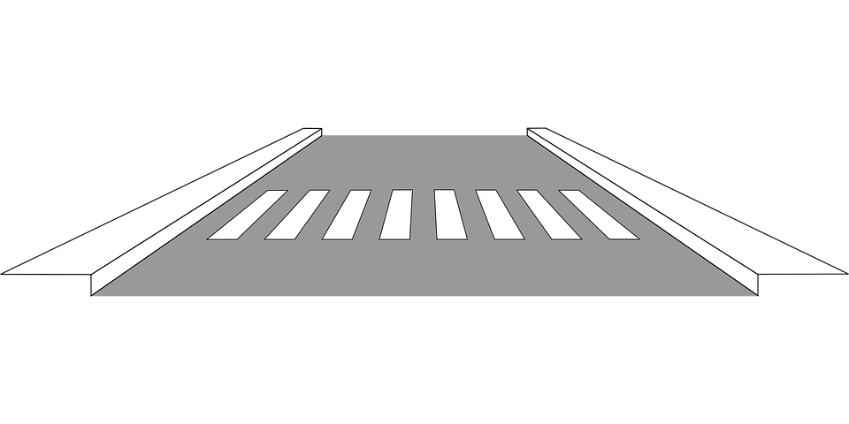Your street will be repaved March 20th & March 21st

**Paving Services provided by your HOA.**

Your street will be “milled” on March 20th- whereby the top layers of your existing street are removed. Traveling on street this day might be delayed due to machinery in area. However, once machinery passes, you are fine to enter/exit street. On March 21st, your street will have new pavement installed. **Travel on your street this day will be delayed**.

In order to limit delays & obstacles, we ask that you park your vehicle(s) fully on your driveway or on Mackay Road along the entrance to Williamsborough Commons.

**Do not park on Planterswood Trail or Gatehouse Lane 3/20-3/21/25**

**Any vehicle impeding our project will be towed at owners’ expense.**

Project schedule contingent on weather conditions. Please call office for further information.

More streets within your community will be repaved in 2025. When those streets are identified and scheduled

a future notice will be sent.

336-315-2187

[manager@adamsfarm.org](mailto:manager@adamsfarm.org)

**Adams Farm Community Association, Inc.**